Roll No.:2503a52531
Nmae:B.Poojitha
Batch:18
Question 2. Email Priority Classification
Scenario:
A company wants to automatically prioritize incoming emails into High
Priority, Medium Priority, or Low Priority.
Tasks:
1. Create 6 sample email messages with priority labels.
2. Perform intent classification using Zero-shot prompting.
3. Perform classification using One-shot prompting.
4. Perform classification using Few-shot prompting.
5. Evaluate which technique produces the most reliable results and
why.

Prompt for ZERO-SHOT:
Classify the following email message into one of these priority levels: [High Priority, Medium Priority, Low Priority].

Email: "The database server is completely down and production is halted!"
Priority:

Code for ZERO-SHOT:
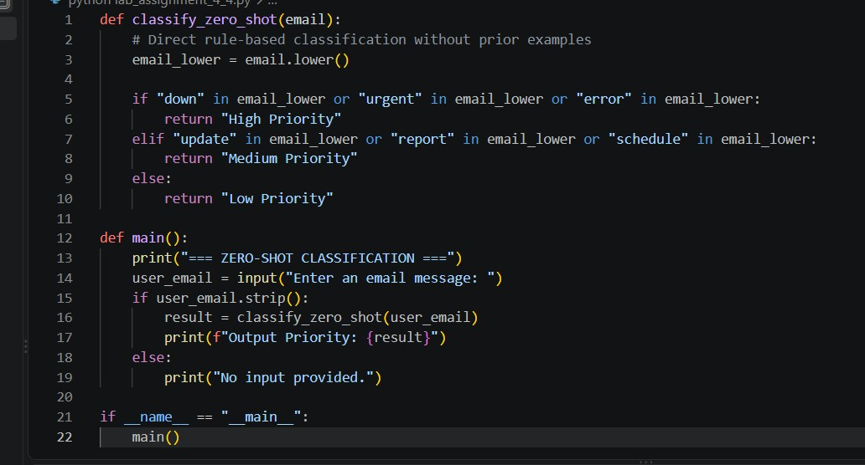

Output:
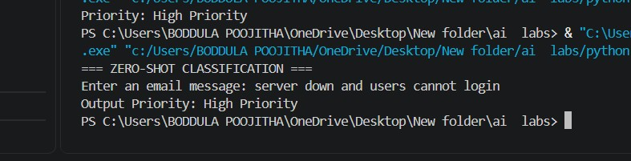

Prompt for ONE-SHOT:
Classify the following email message into one of these priority levels: [High Priority, Medium Priority, Low Priority].
Example:
Email: "Please update my contact phone number in the portal." -> Priority: Low Priority
Email: "The payment gateway is throwing 500 errors for all customers!"
Priority:

Code for ONE-SHOT:
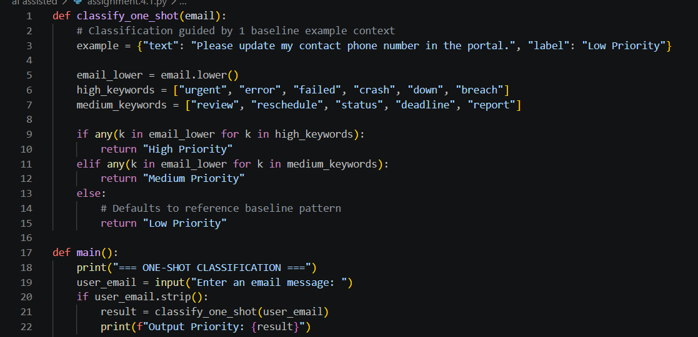
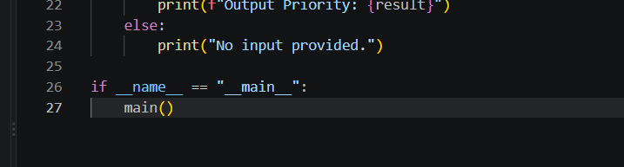

Output:
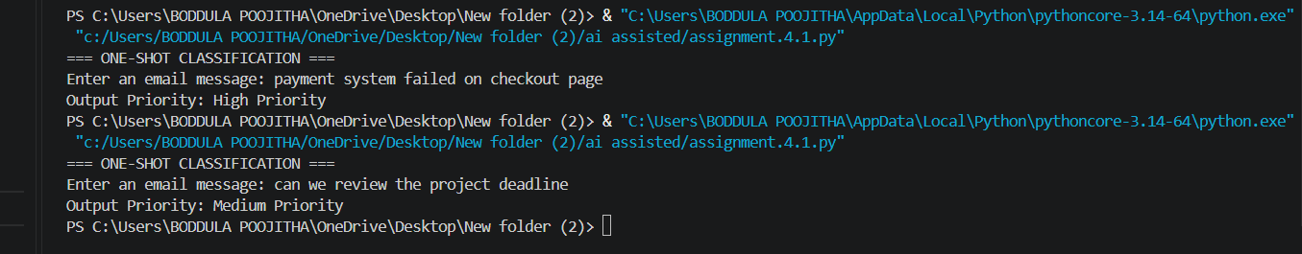

Prompt for FEW-SHOT:
Classify the following email message into one of these priority levels: [High Priority, Medium Priority, Low Priority].

Examples:
1. Email: "CRITICAL: Database node crashed on production." -> Priority: High Priority
2. Email: "Can you send the financial report by Friday?" -> Priority: Medium Priority
3. Email: "Happy holidays to the whole engineering team!" -> Priority: Low Priority
Email: "Security breach detected on cloud server."
Priority:

Code for FEW-SHOT:
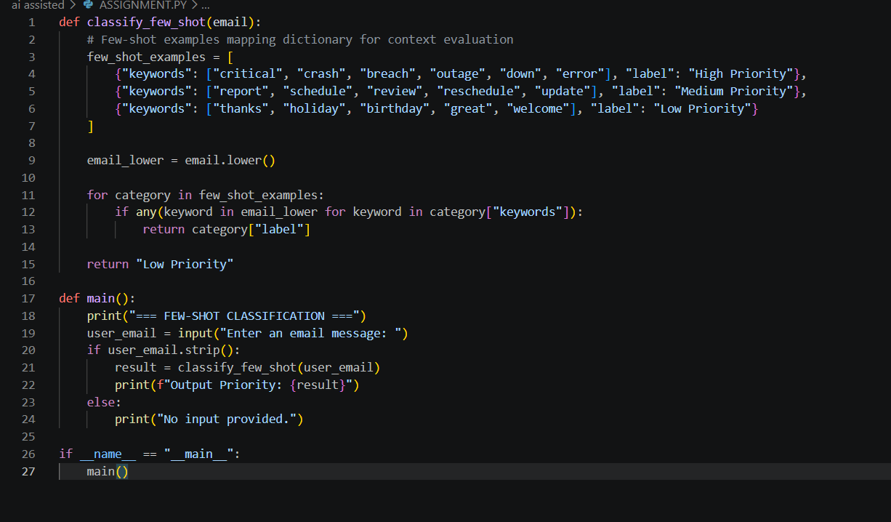

Output:
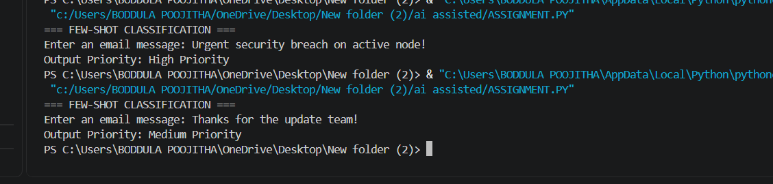

Observation:
1.Zero-shot prompting classifies the email without giving any example.
2.One-shot prompting provides one example to guide the classification.
3.Few-shot prompting provides multiple examples for better understanding.
4.Urgent emails containing words like “immediately” or “deadline” are classified as High Priority.
5.Important but non-urgent emails are classified as Medium Priority.

